# Map()

## It creates a new array from calling a function for every array element.

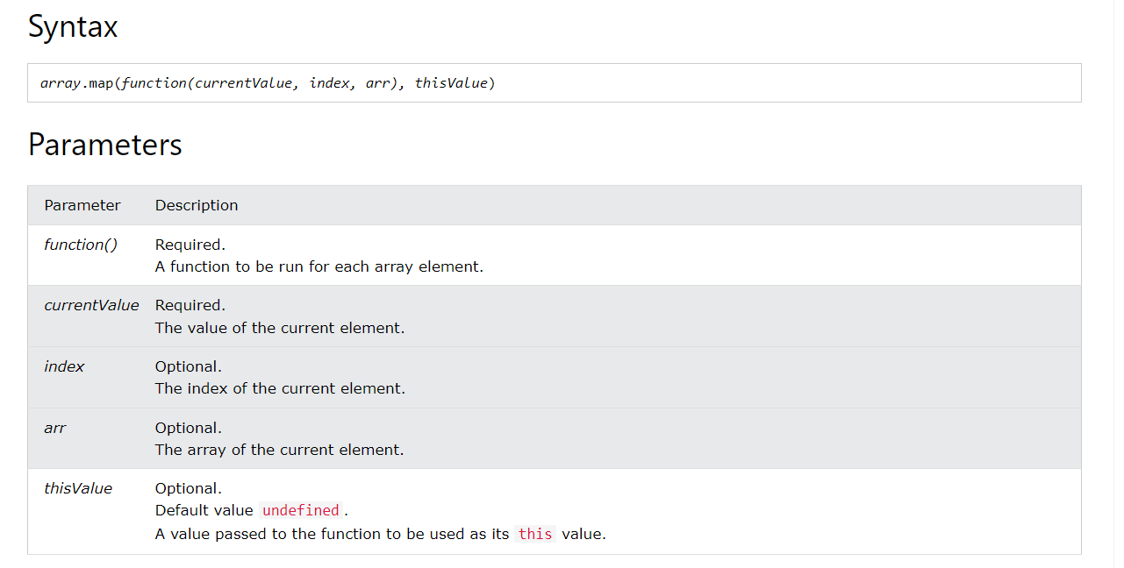

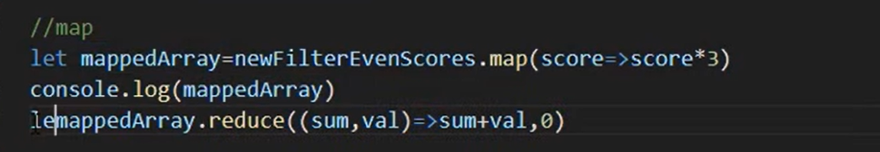

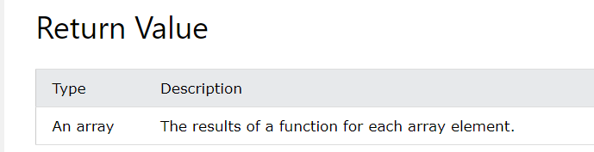

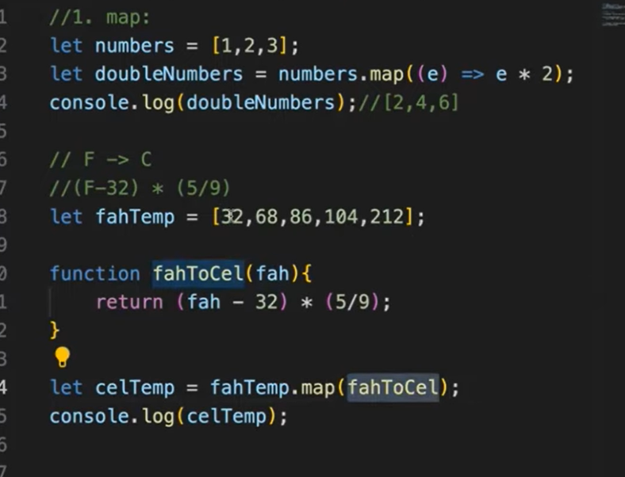

# Sort()

## Sorting alphabetically works well for strings ("Apple" comes before "Banana").

## But sorting numbers can produce incorrect results.

## "25" is bigger than "100", because "2" is bigger than "1".

## You can fix this by providing a "compare function" (See examples below).

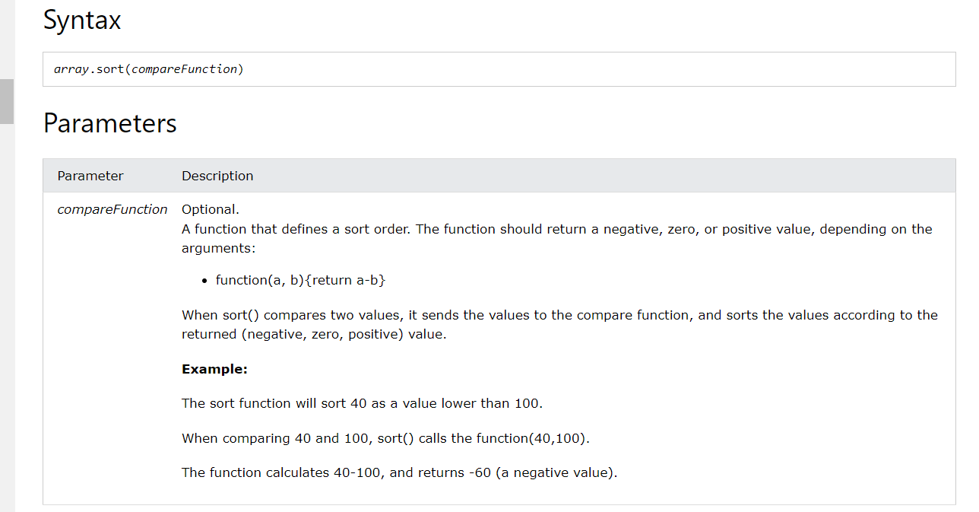

# Every()

## It executes a function for each array element.

## It returns **true** if the function returns true for all elements.

## It returns **false** if the function returns false for one element.

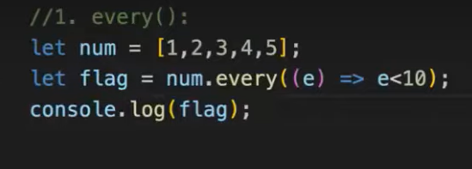

# Some()

## checks if any array elements pass a test (provided as a callback function).

## executes the callback function once for each array element.

## returns true (and stops) if the function returns true for one of the array elements.

## returns false if the function returns false for all of the array elements.

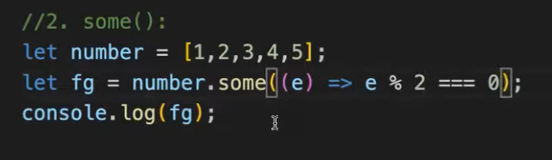

# Find()

## returns the value of the first element that passes a test.

## executes a function for each array element.

## returns undefined if no elements are found.

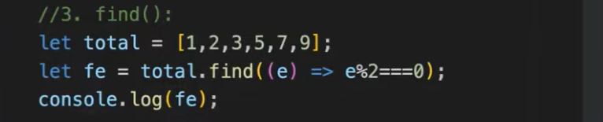

# String

## JavaScript strings are primitive and immutable: All string methods produces a new string without altering the original string.

# Length property

## The length property returns the length of a string.

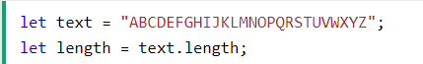

# Split()

## A string can be converted to an array with the split() method.

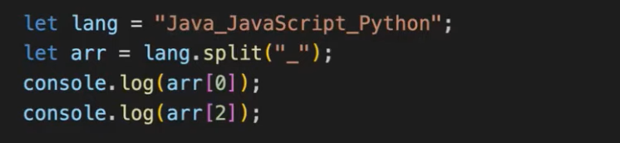

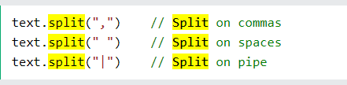

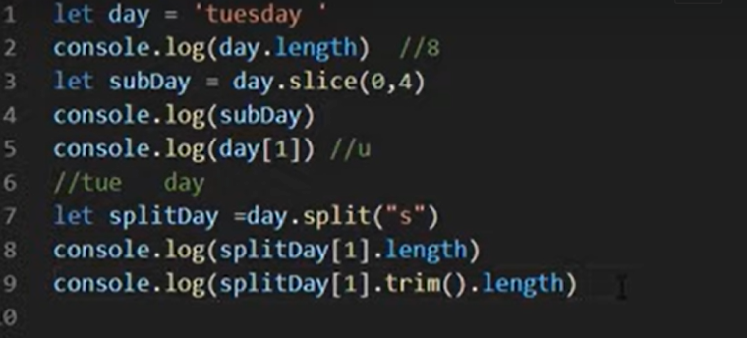

# Slice()

## It extracts a part of a string.

## The first position is 0, the second is 1, ...

## A negative number selects from the end of the string(starts from -1 from right to left.

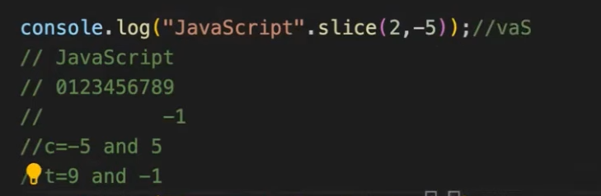

# Trim()

## To remove leading and trailing spaces.

# TrimStart()

## Remove only the leading spaces.

# trimEnd()

## Remove only the trailing spaces.

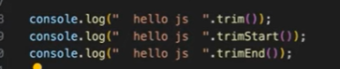

# padStart()

## It pads a string from the start.

## It pads a string with another string (multiple times) until it reaches a given length.

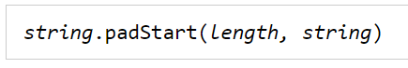

# padEnd()

## It pads a string at the end.

## It pads a string with another string (multiple times) until it reaches a given length.

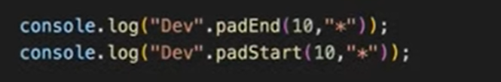

# startsWith()

## method returns true if a string starts with a specified string.

## Otherwise, it returns false.

## Case Sensitive

# endsWith()

## returns true if a string ends with a specified string.

## Otherwise, it returns false.

## Case Sensitive

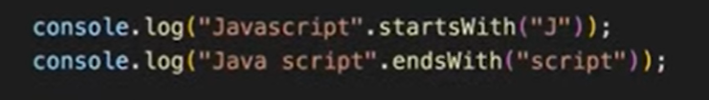

# Repeat()

## returns a string with a number of copies of a string.

## returns a new string.



# indexOf()

## returns the position of the first occurrence of a value in a string.

## returns -1 if the value is not found.

## Case-Sensitive

# lastIndexOf()

## returns the index (position) of the last occurrence of a specified value in a string.

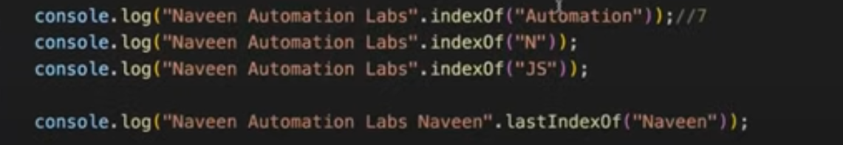

# Search()

## returns the index (position) of the first match.

## returns -1 if no match is found.

# Date Object

## To create date object, use new keyword.

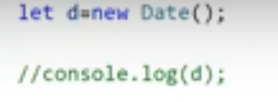

# To get date: getDate() method

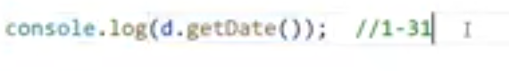

# To get month: getMonth() method

## Month index will start from 0.



# To get year: getFullYear() method



# To print complete



# To get hours: getHours()



# To get hours: getMinutes()



# To get hours: getSeconds()



# To print complete time.



# Function to showtime

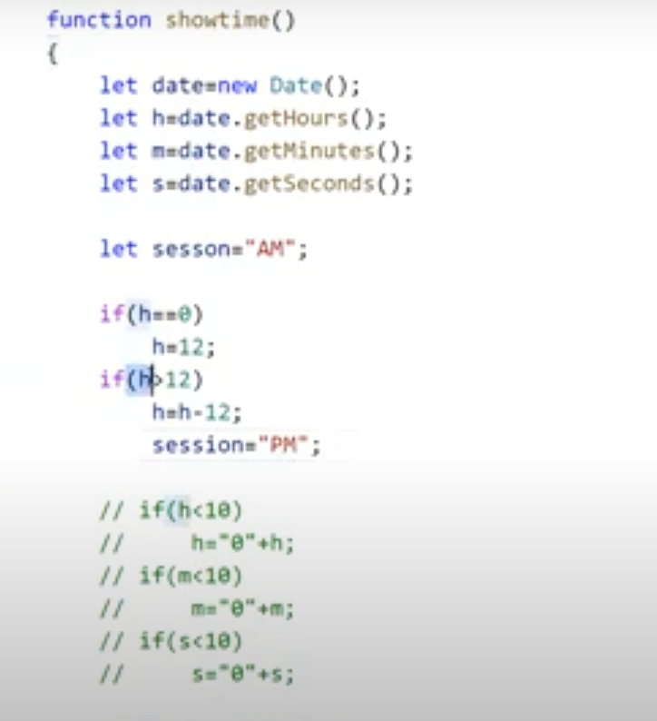

# Using ternary operator

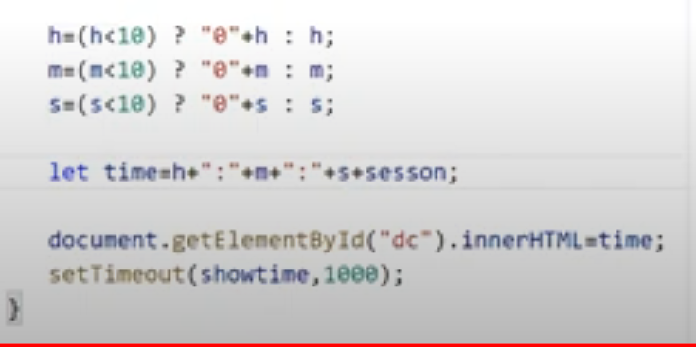

# Numbers and Strings Object

## Predefined object in JavaScript.

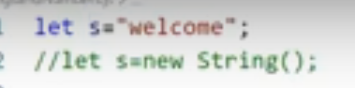

# charAt()

## Returns the character from the specified index.

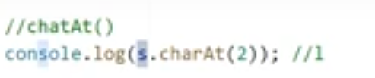

# charCodeAt()

## Returns the ASCII value of the character.

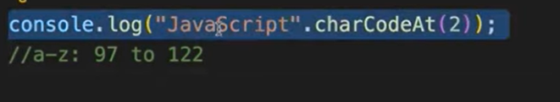

# Concat()

## It joins two or more strings.

## It does not change the existing strings. It returns a new string.



# replace()

## It returns a new string with the value(s) **replaced.**

## Replace only the first value if it has duplicates.

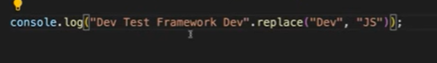

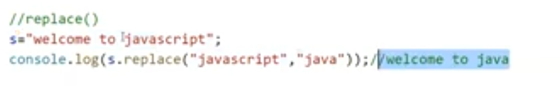

# replaceAll()

## To replace all values(- with/)





# substring()

## It extracts characters from start to end .

## The negative index will be converted to 0 but in slice we have to go from right to left if negative.

## It does not change the original string.

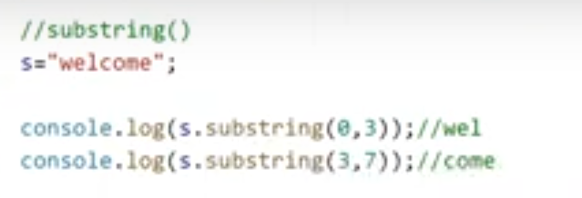

# toUpperCase() and toLowerCase()

## Converts all lower-case characters to upper case character.

## Converts all upper-case characters to lower case character.

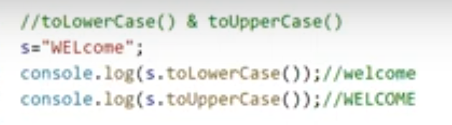

# Split()

## Split the entire text based on delimiter.

## If space sentence has space, then split by space or any characters.

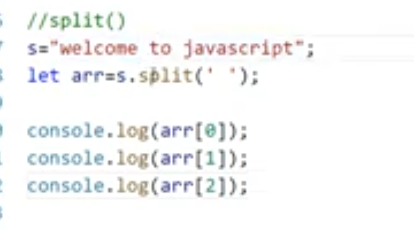

# Trim()

## Removes trailing and leading spaces.

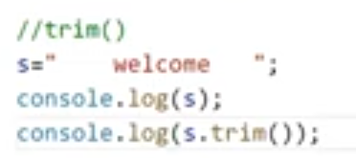

# Numbers

## Predefined object in JavaScript.

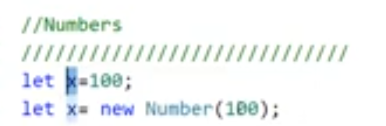

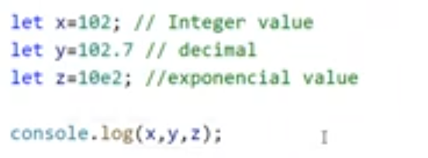

# isInteger()

## All the number methods we must access it using Number object.

## Return true if the variable is integer.

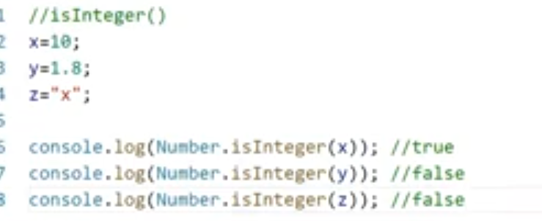

# parseInt()

## Converts String into Integer

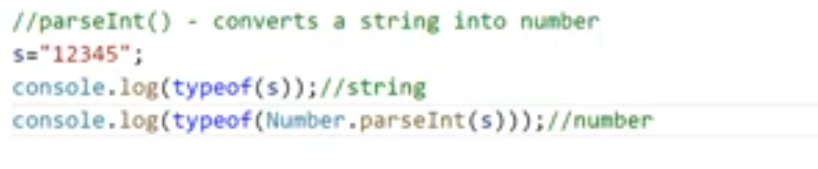

# parseFloat()

## It is used to accept the string and convert it into a floating-point number.

## If the string does not contain a numeral value or if the first character of the string is not a Number then it returns NaN i.e, not a number.

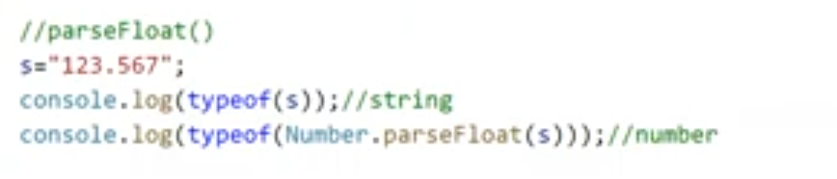

# toString()

## Converts numbers into String.

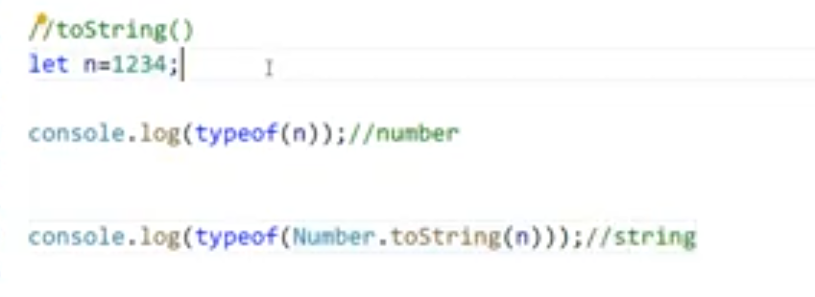

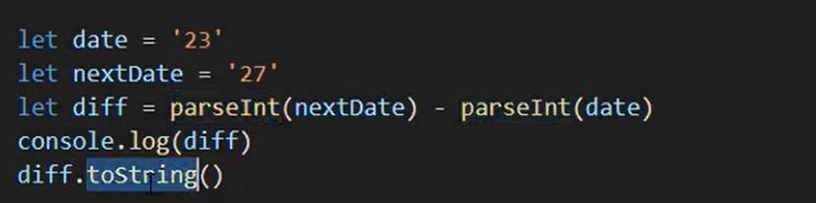

# OOPS concept:

# Difference between classes and objects

## Class representation is dynamic so that we can create n number of objects. For all those persons this class will be on common entity.

# Class

## It is a collection of variables and methods.

## Class(logical entity) doesn’t occupy space in memory, but object will occupy(physical entity).

## We can create any number of objects for one class.

# Local Variable

## It is declared inside a specific function and can only be accessed by the function in which it is declared.

# Global Variable

## Global variables are those defined outside of any function, making them accessible from anywhere within the script.

# This keyword

## this is not a variable – it's a keyword, so its value can't be changed or reassigned.

## If we want to make the variables belong to the class, then use this keyword.

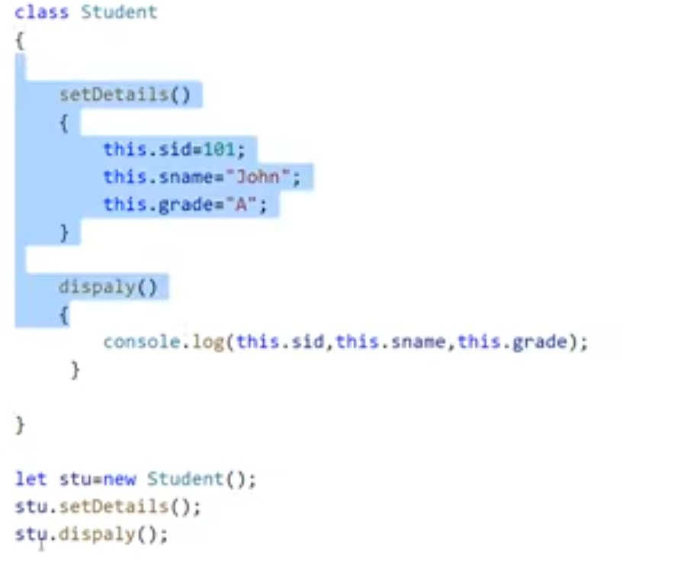

# Constructor

## It is used for only initializing the data.

## It can also take arguments.

## Whenever we create an object constructor will automatically be invoked so we don’t need to call the constructor by using object name. It’s not like method.

## Keyword to create constructor : **constructor**.

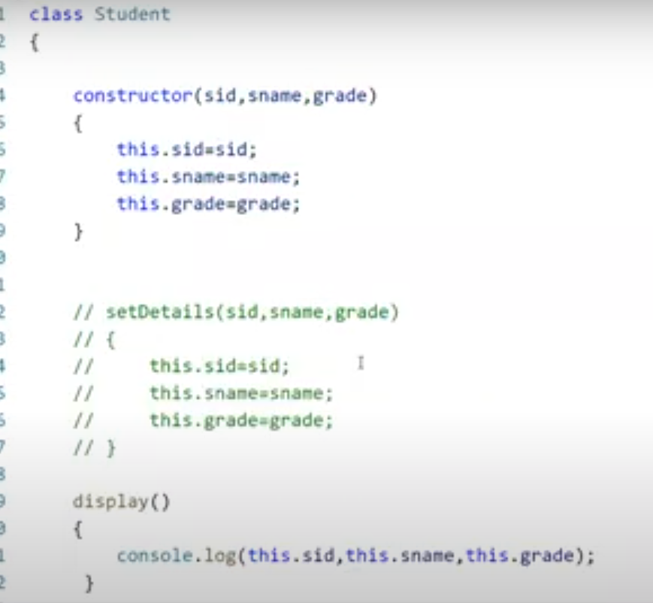

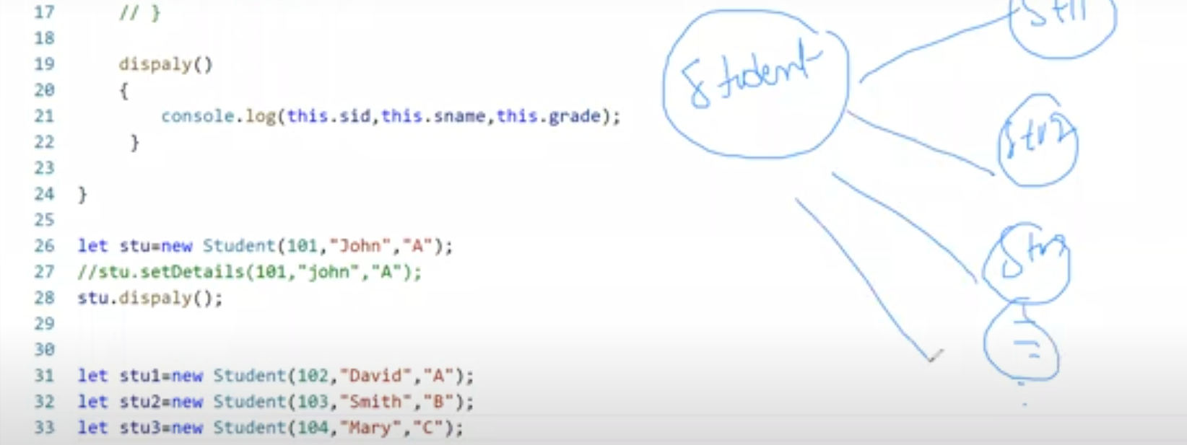

## It is method which executes by default when you create object of the class.

## If we declare any properties/arguments in constructor those are like instance variables.

## At runtime we will be sending the data(firstname and lastname) inside the class creation. When object is created the constructor will be called by default and so those data will go and sit inside the constructor parameters(firstname, Lastname).

## But from there(constructor) it should be accessible across our class. But the scope of values/data will be only inside the constructor method. To get the scope to outside we have to create new property for this class.

## This represents current class object. So from current class object I am creating one property and that property will be accessible to entire class for that property we are sending the value(firstname..etc).

## Now this.property will get activated and can be used across the class. We cannot use directly that why we brought another variable of this class and scope is entire class by using this keyword.

# If we want to have new different values for objects

## We are sending the firstname etc values at runtime to constructor. As these values are changing based upon the instance what we create we called the constructor variables are instance variables

# Method is different from constructor:

## Method will do some complex operation, perform logics, takes arguments, must be called explicitly, access through object only.

# Static Keyword

## We create static property/variables/methods when we see all the objects have only one common value.

## The methods and variables which are declared as static will be used common across multiple objects.

## It creates separate memory for static variable and methods only one time. It will not occupy many times in object level.

## We can directly access the static variables and methods using class name we don’t want to create any object(memory management keyword) for that.

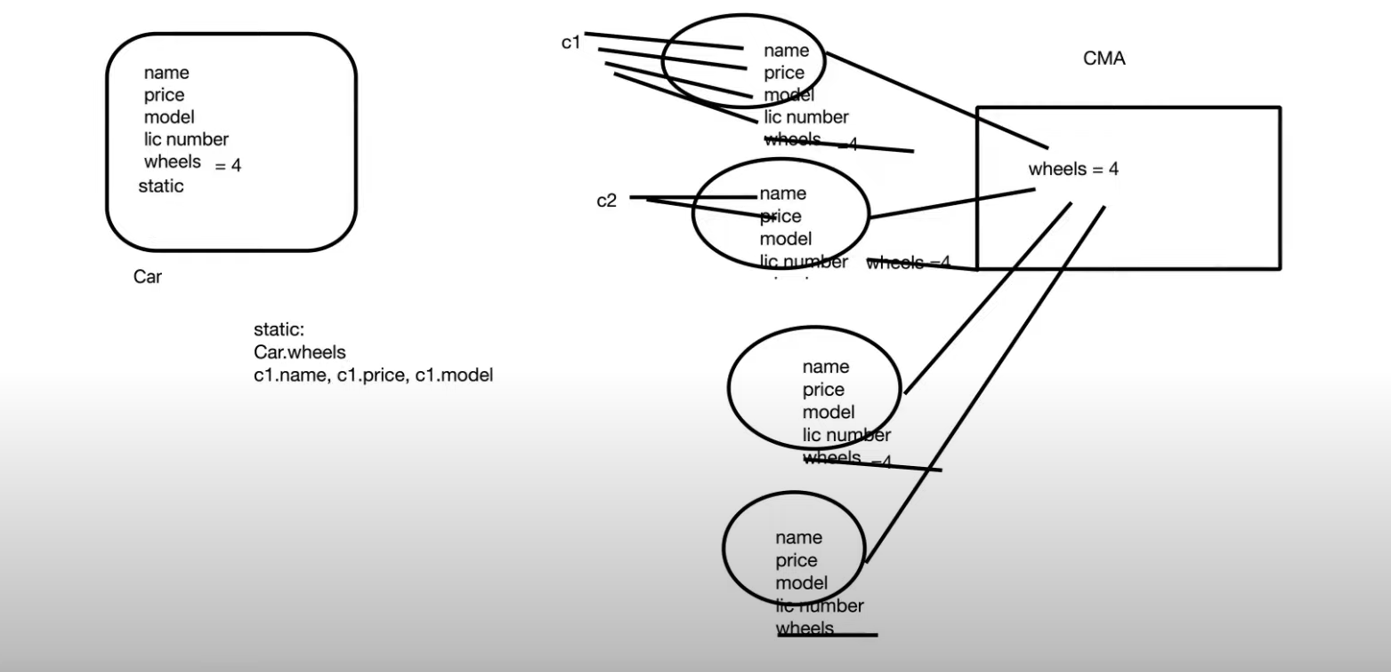

# Non-static:

## We cannot directly access the non-static variables and methods using class name we must create object for that and using that class object we must access.

## Non-static methods can access any static method and any static variable without creating an instance of the class.

## Allocated in heap memory and created for each object.

# 

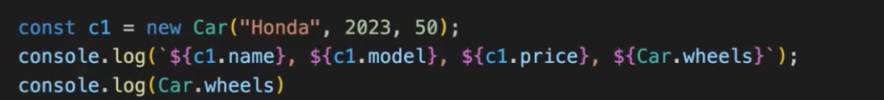

# After modifying the static variable value:

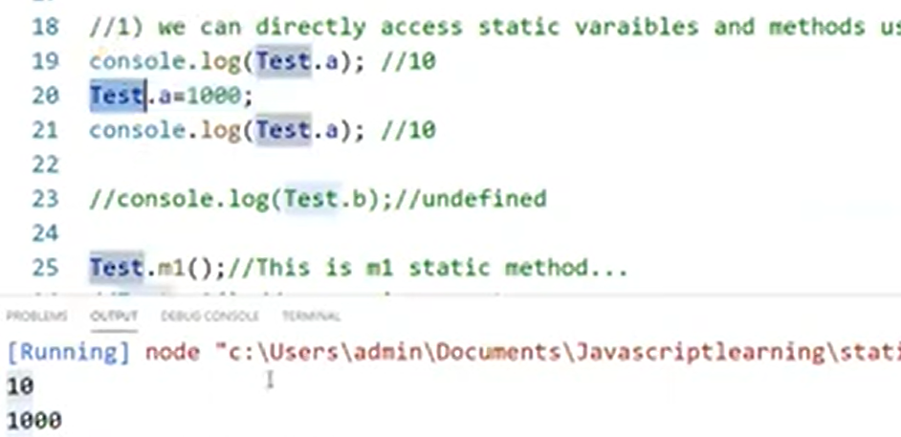

# Encapsulation

## It binds code and data(variables) into single unit.

## We define the data and to work on the data we create a function. All the function along with the data present in one entity which we say as class.



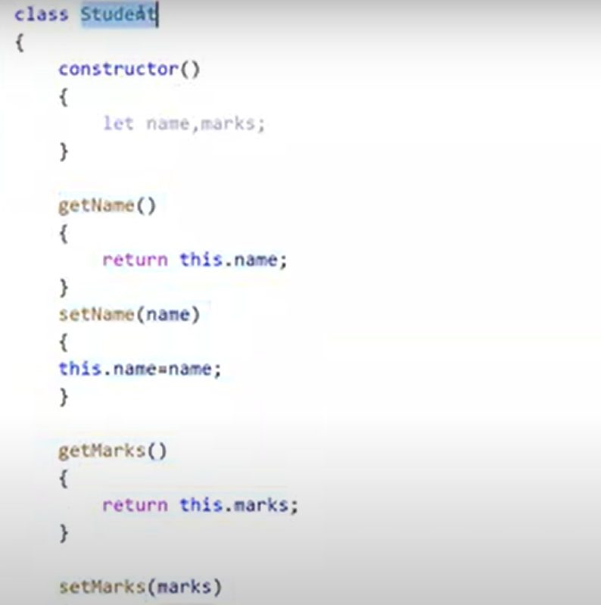

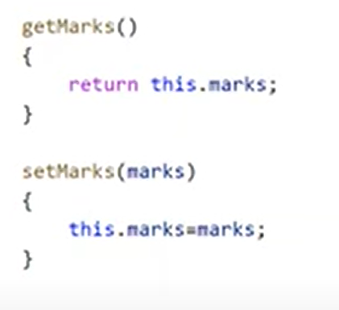

# Inheritance

## Whatever methods and variables created in class A(parent/super) now I want to reuse the same methods and variables in another class B(child/sub/derived).

## So, using inheritance we can do that.

## Using extends keywords we can do that.

## If parent class has any constructor, then child class also should implement same kind of constructor. That is rule of inheritance.

## In Parent constructor what all arguments we are passing we must give same argument in child class constructor by using **super** keyword.

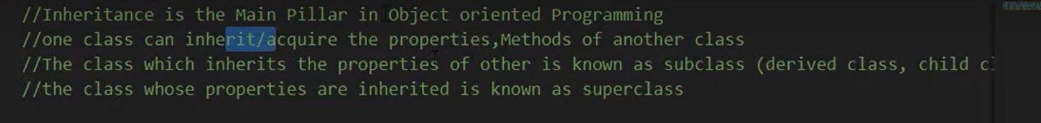

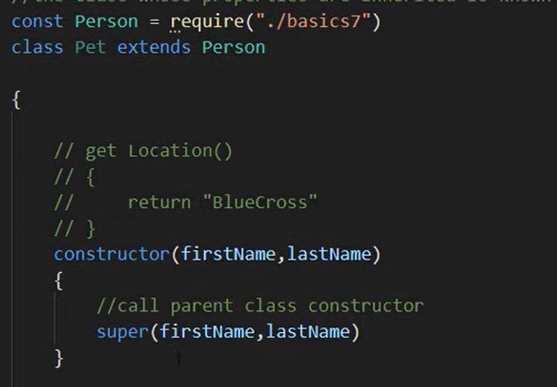

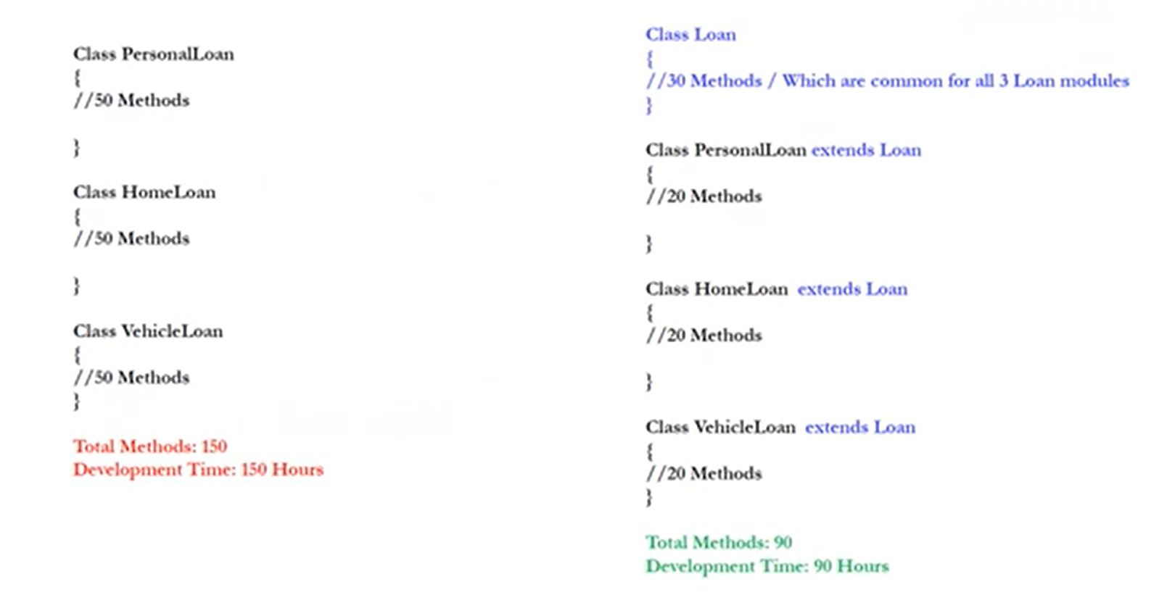

# Single Inheritance

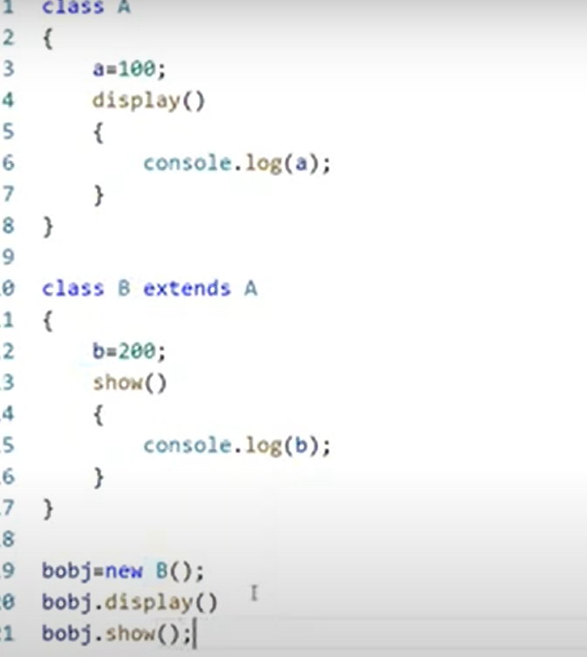

# Overriding

## If we don’t want to use the parent class method but I want to override that method in child class.

## If parent class and child class have same method name and parameters then it is method overriding.

## If we extend parent class but I don’t want to implement the same kind of method used in parent class so we can re-create the same method in child class.

## Parent cannot take anything(methods, variables etc) from the child but only child can inherit all the properties from parent.

## **Method name, argument** cannot be changed. Only the body(contents can be changed).

# Overriding Example with hierarchy inheritance

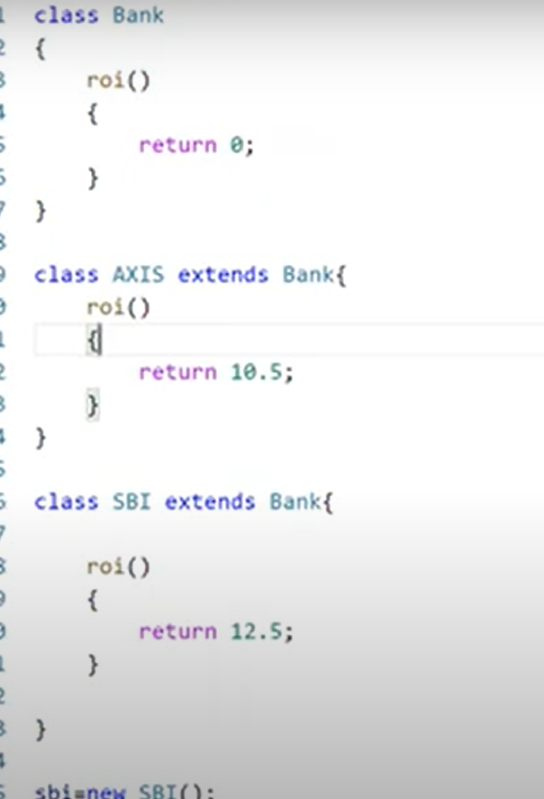

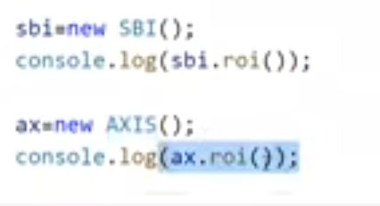

# Super keyword in inheritance

## Used to call parent class constructor.

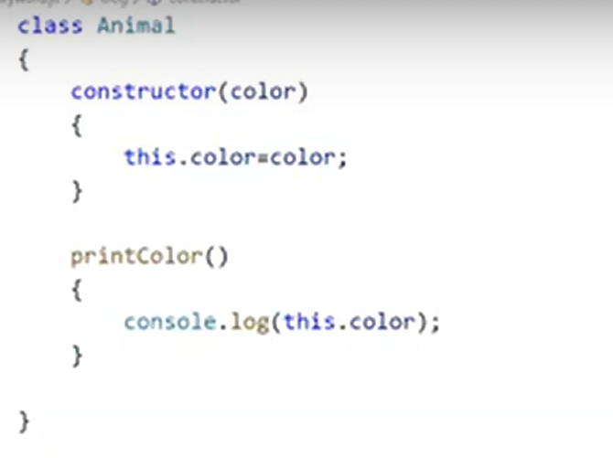

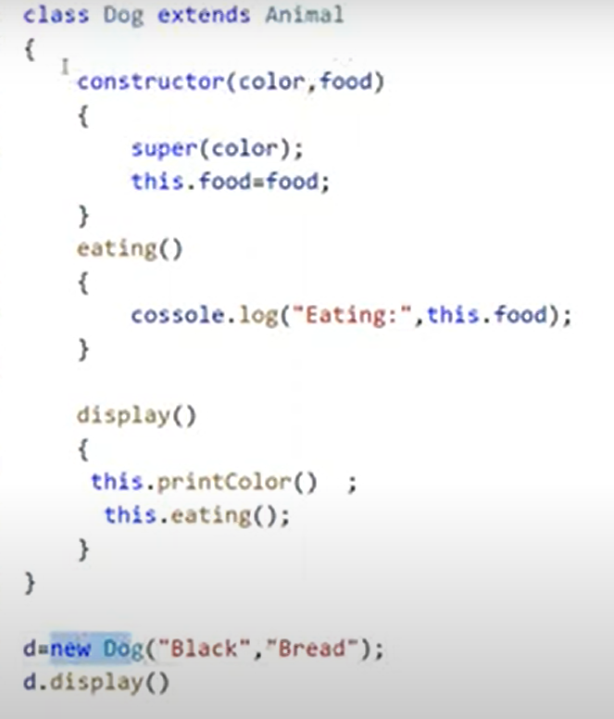

# Prototype

## It is an object that is associated with every function and object by default.

## If we want to add new properties at later stage to function/class, we can take help of prototype.

# Add new property to function:

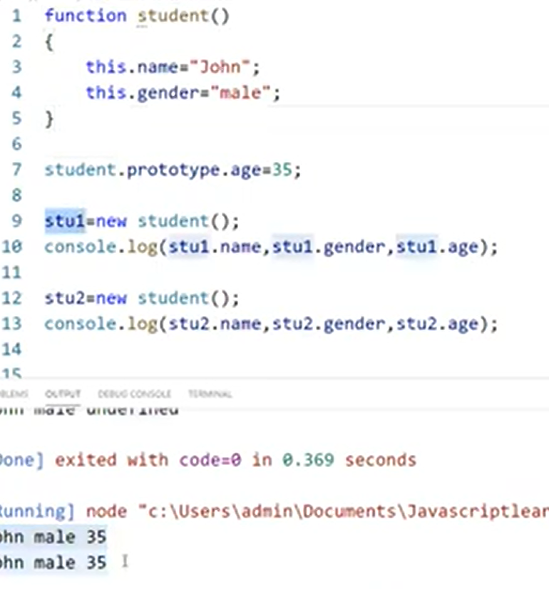

# Add new property(variable or attribute) to class:

## We can also add methods or functions to class using prototype.

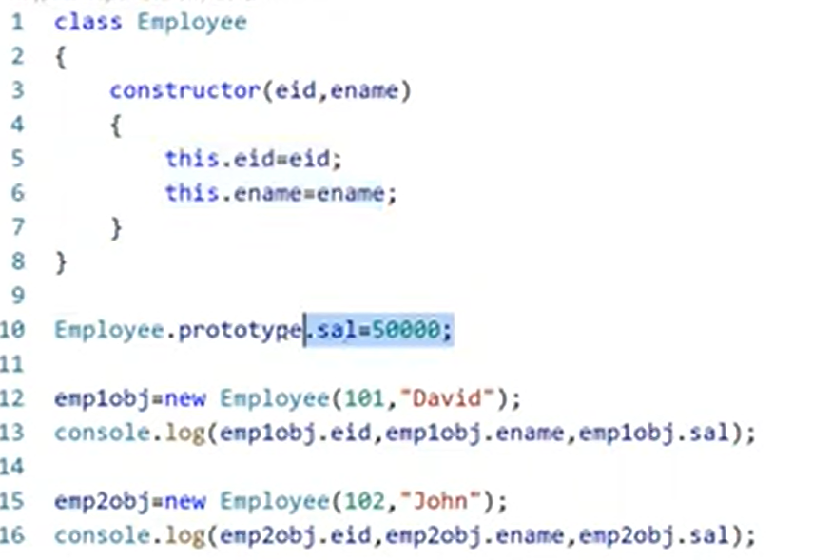

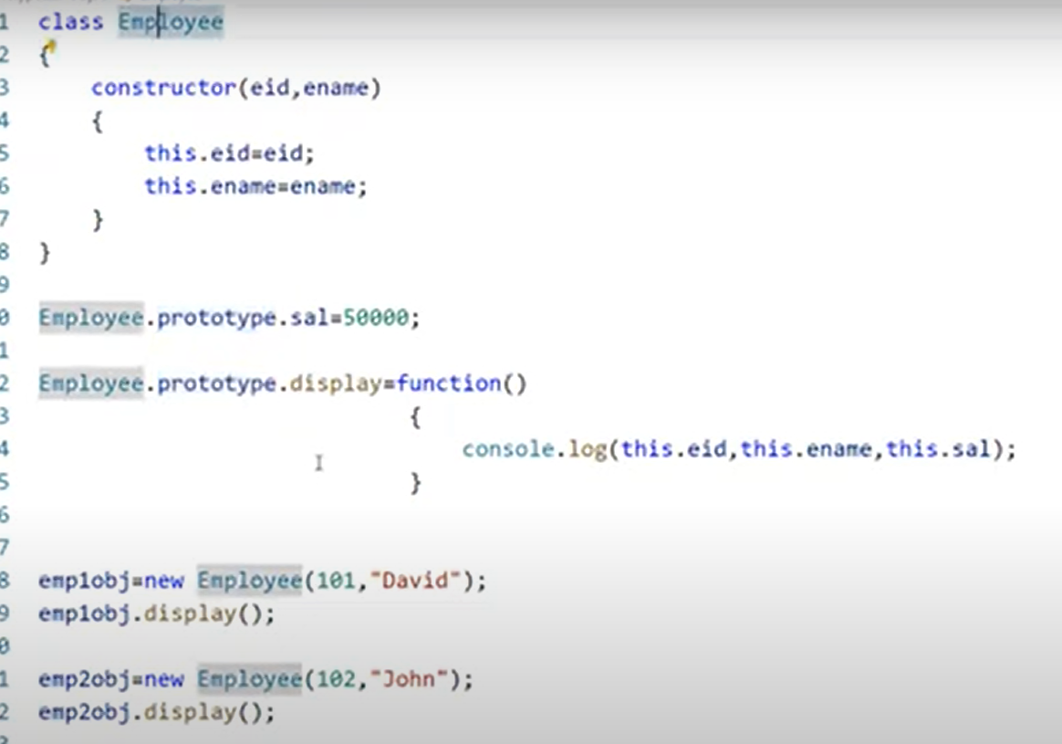

# Polymorphism

## Many forms.

## Ability to create a variable, function, object that has one or more forms.

# Method Overriding

## Same method has three different forms.

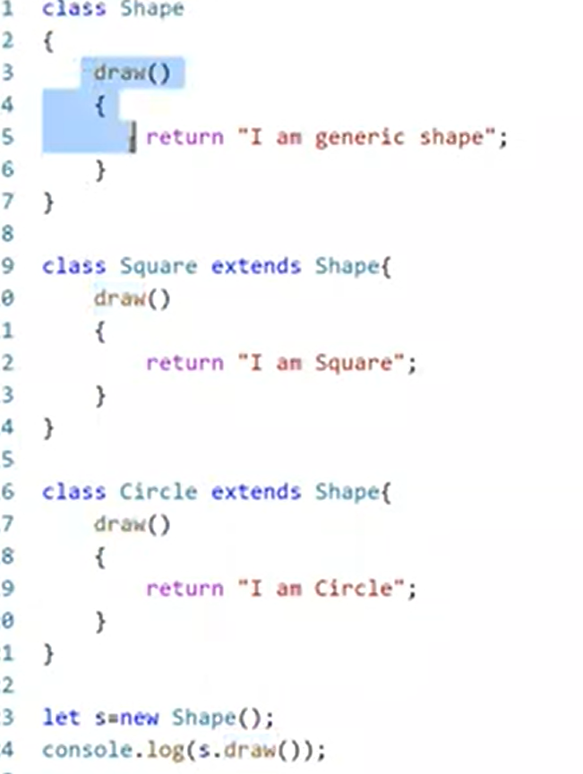

# Read JSON data to JavaScript Object using JavaScript:

## First, we must convert JSON data into Java Script Object

## Then from that object we must extract that data.

# Simple data

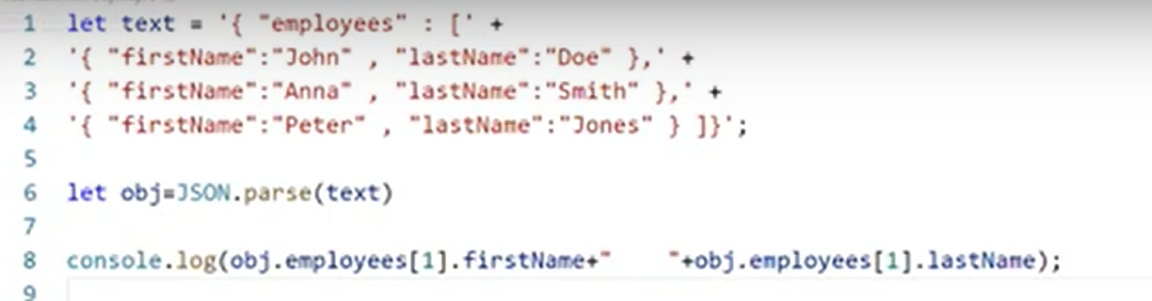

# Complex data

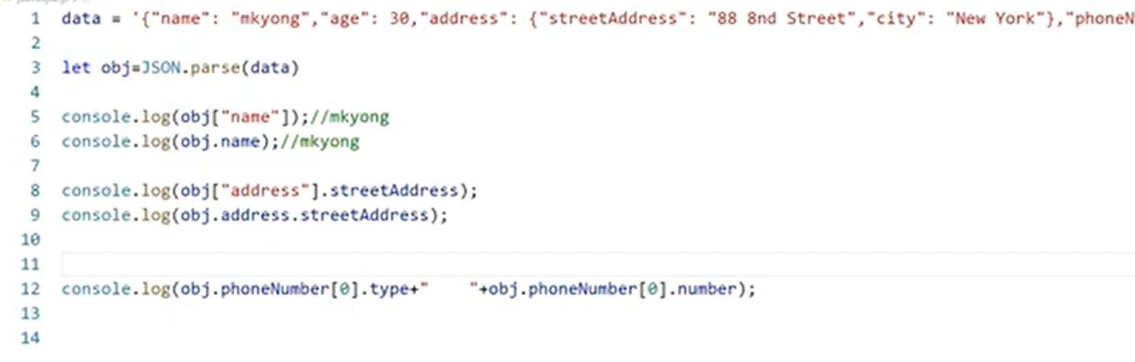

# Call back function

## It is a specific function that is passed as an argument to another function.

## Once main function/task is completed then only call back function will be called.

## We will call a specific function by passing a specific function.

## When you pass a function as an argument, remember not to use parenthesis.

## Where callbacks really shine are in asynchronous functions, where one function must wait for another function (like waiting for a file to load).

## Sometimes you would like to have better control over when to execute a function.

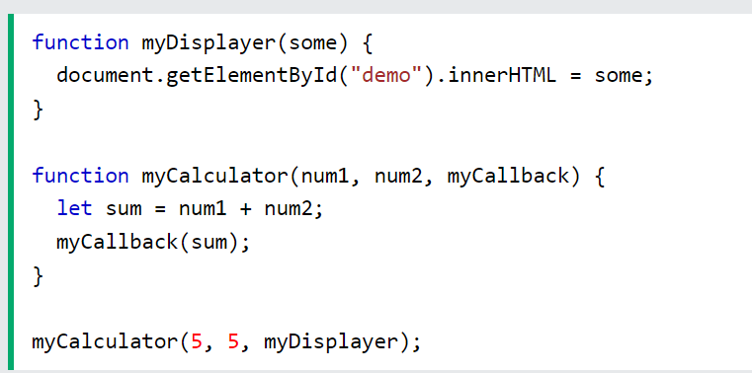

# Asynchronous

## Functions running in parallel with other functions are called asynchronous.

## Handle multiple tasks simultaneously rather than executing them one after the other.

## But asynchronous programs are difficult to write and difficult to debug.

## Because of this, most modern asynchronous JavaScript methods don't use callbacks. Instead, in JavaScript, asynchronous programming is solved using **Promises** instead.

# Promises

## Way to handle asynchronous operations in a more organized and readable manner.

## Provide cleaner syntax when compared to traditional call back approaches.

## Promise is a class in JavaScript.

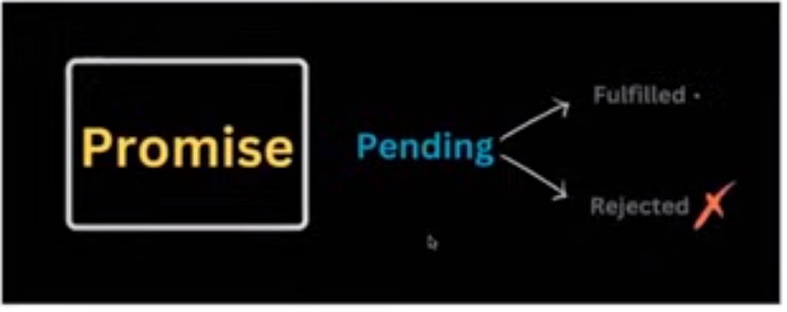

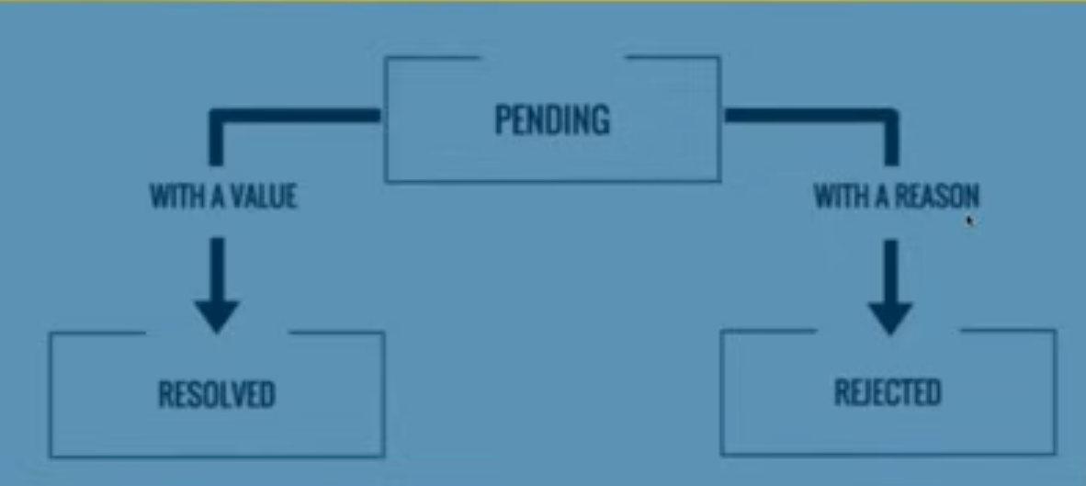

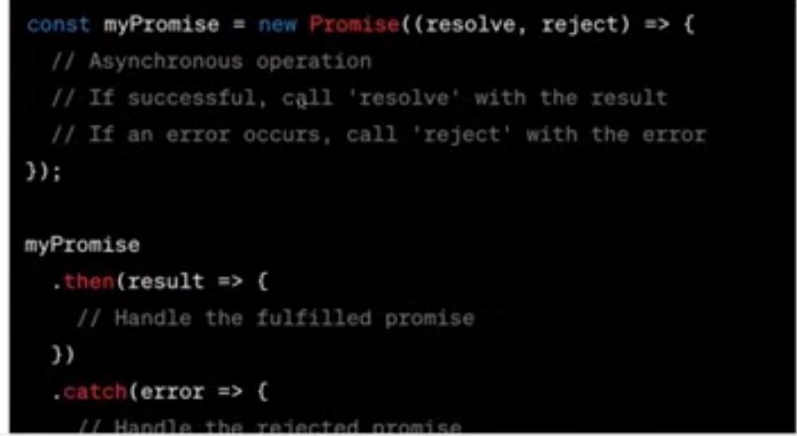

## If random value is greater than 0.5 then it will resolve the promise and use, then to print the statement .

## If it is smaller, then it will reject the promise and use catch to print the error.

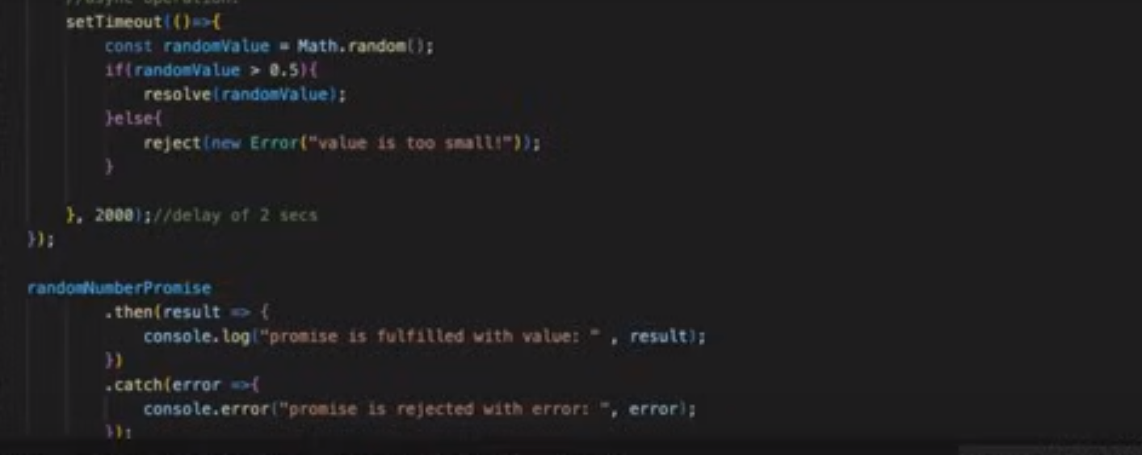

# Promise Chaining

## Promise Chaining is a simple concept by which we may initialize another promise inside our **.then()**method and accordingly we may execute our results.

## The function inside then captures the value returned by the previous promise.

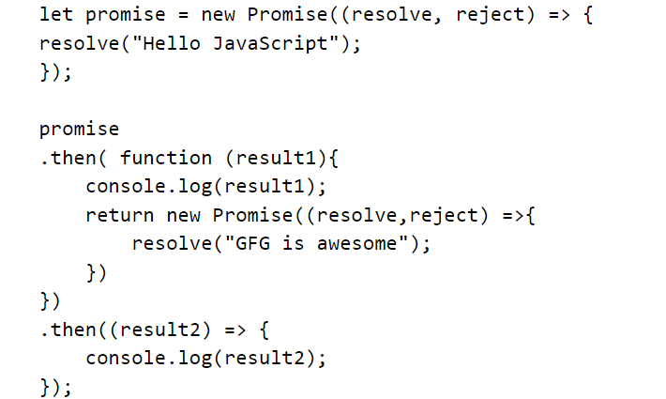

# Promise.all()

## It combines all the user-defined promises and returns a single promise in the form of an array in which the result is the sequential combination of all the promises.

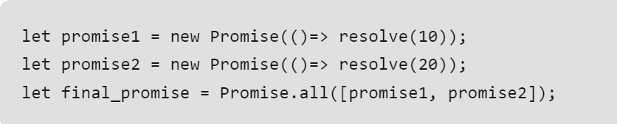

## If both the promises are fulfilled/resolved then it will return that in the array.

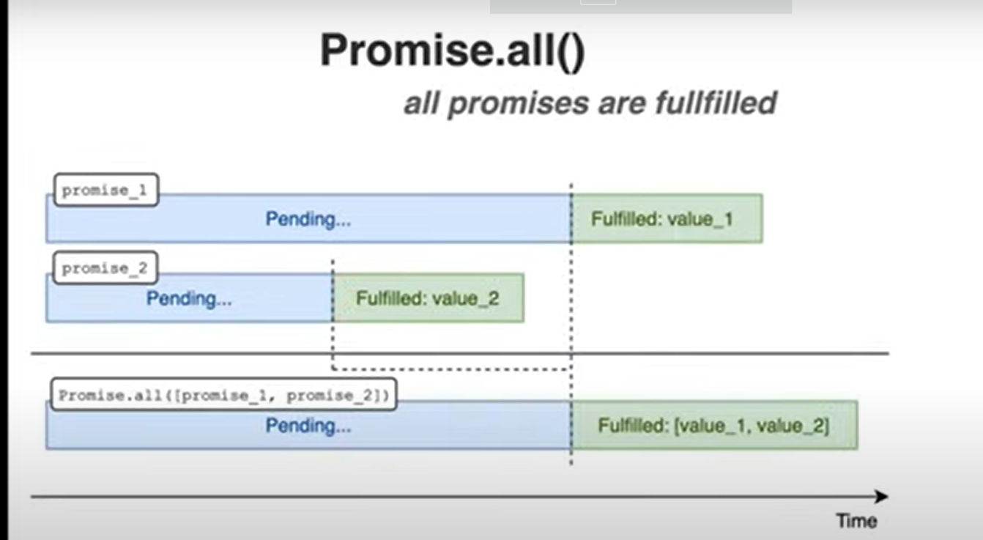

# If anyone of the promise is rejected, then it will send the rejected promise

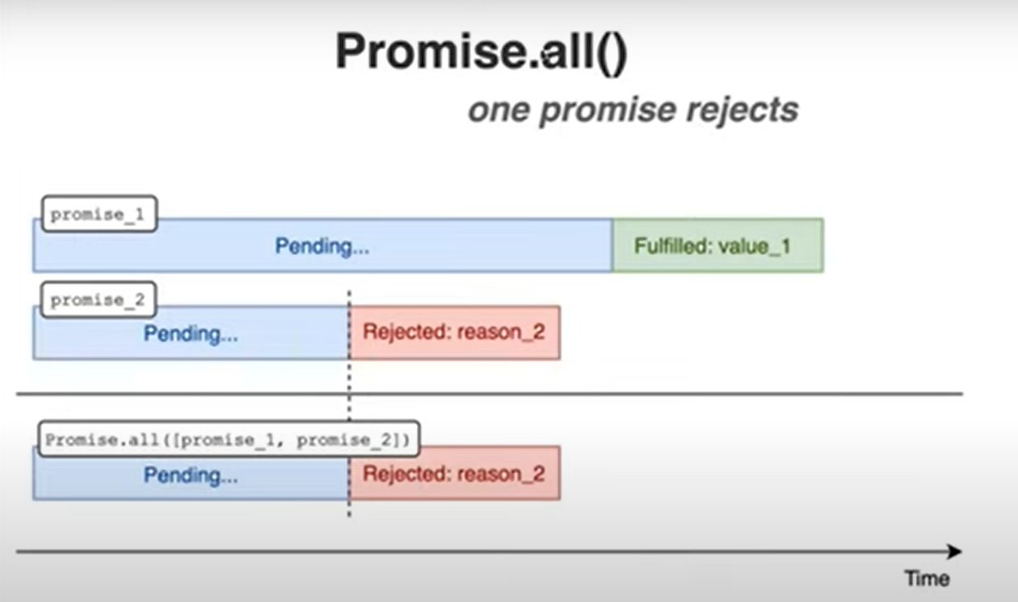

# Promise.AllSettled()

## It is useful when you want to process all promises whether they succeed or fail, and you want to gather the information about the out come of each promise.

## In multiple promises some of them got resolved and some of them got rejected so this method will give the result of all the promises separately.

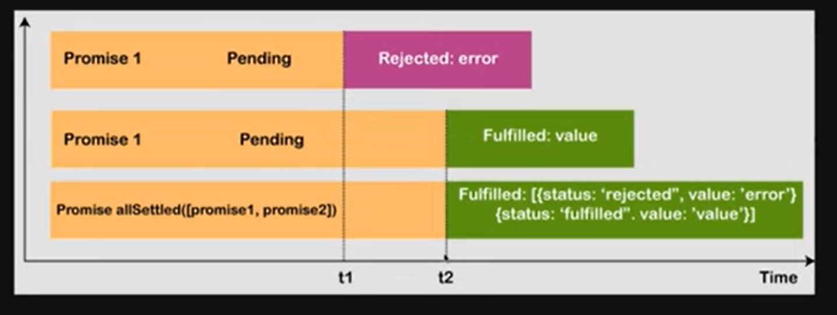

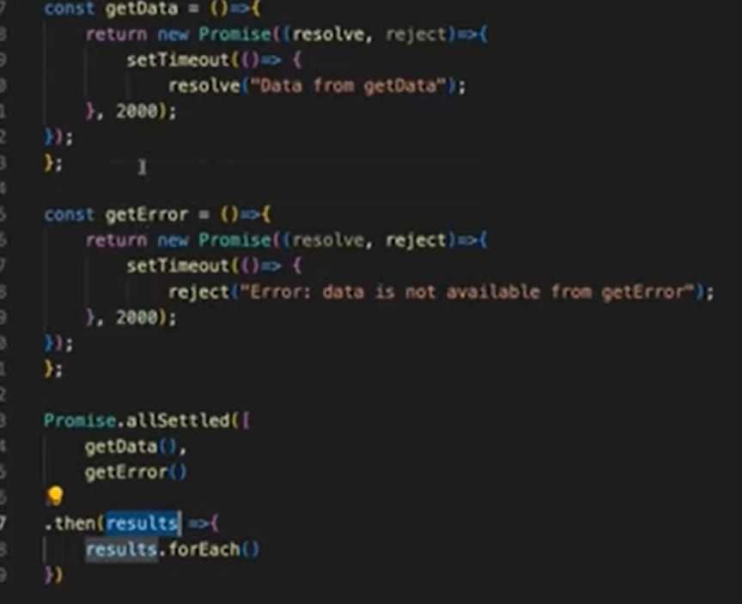

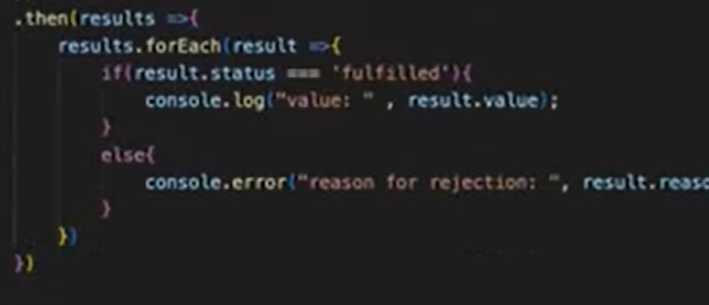

# Promise.race()

## Two promises are running in parallel. Which is taking more time.

## It will return the promise which is completed its execution first.

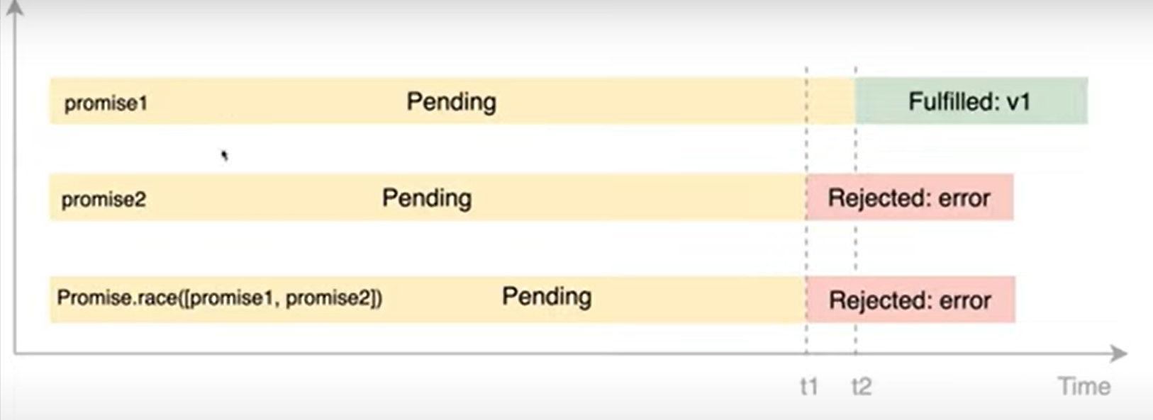

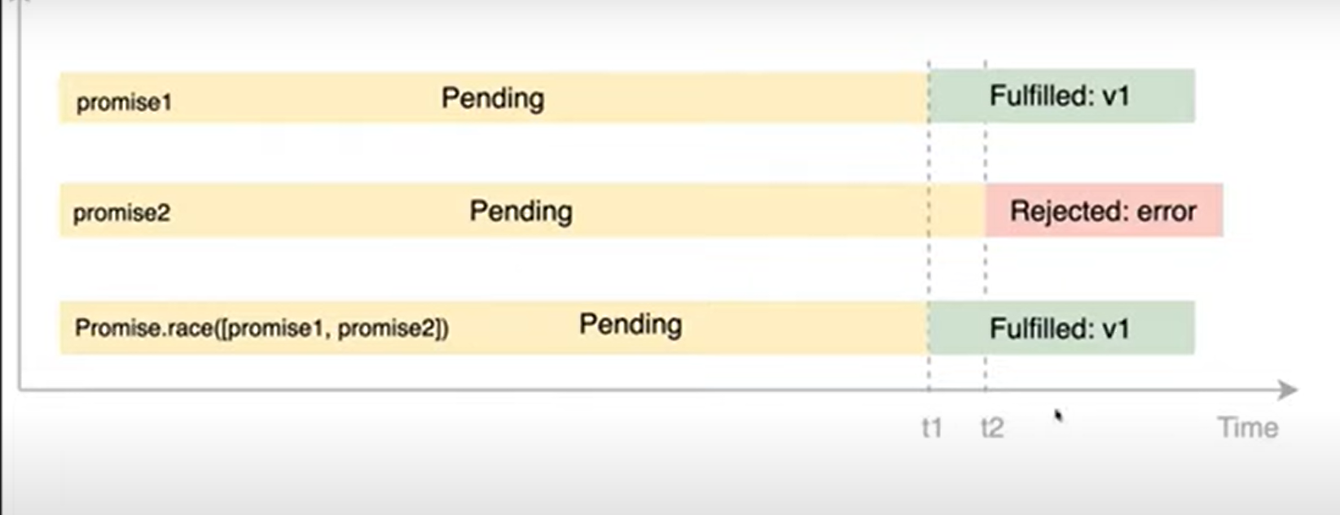

# Promise.any()

## It will always wait for the first resolved/fulfilled promise.

## It returns a single Promise from a list of promises when any promise fulfill.

# Callback Hell or Pyramid of Doom

## Deeply nested call back

## To mitigate this issue JavaScript introduces promises concept and async/await concept.

# Drawbacks

## Horrible Readability

## Bad indentation/alignment of code

## Difficult in Error Handling and Debugging.

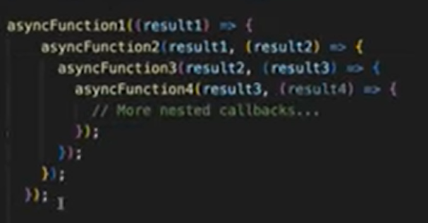

# Async and Await

## Better readability with the promises and call back functions with async operations then the JavaScript introduced async and await concept.

## This is the much better way of handling the asynchronous operation.

## We can now use promise chaining concept or async and await concept to write our code.

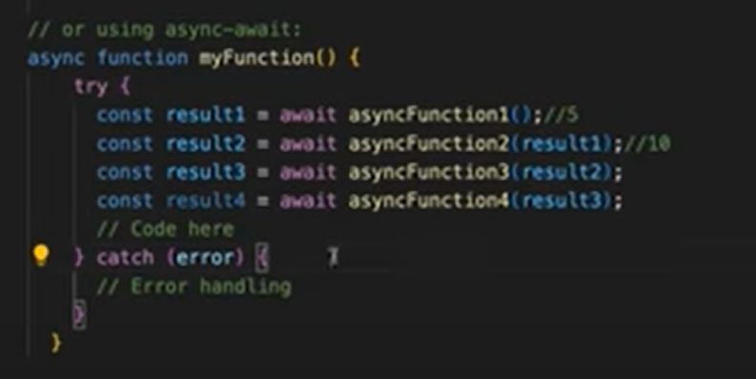

# Aysnc

## Defines that this specific function is asynchronous.

## Modern way of handling async calls/steps.

## Used with promises.

## **async** is a kind of keyword tells that this function is asynchronous, and it will always return the promise. Declare before function.

## **Await** keyword is used only in async functions to wait for the promise to resolve or reject(to completed) then only it must move to next step to proceed.

//async-await - modern way of handling the ayschrnous steps

//mainly it is used with promises only

//async is a kind of keyword tells that this function is asynchronous and it will always return the promise

//Await Keyword is used only in Async Functions to wait for promise.

//in normal function we cannot write await

# Console methods

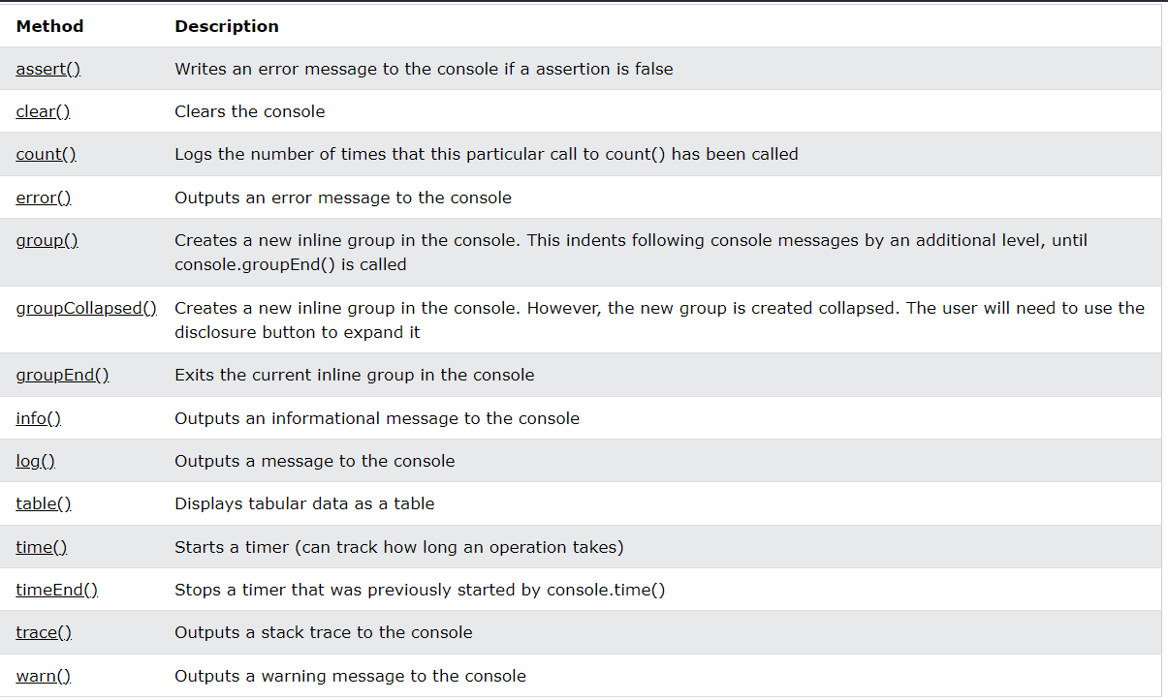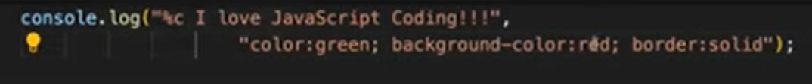

# Template Literals Operator

## If we want to pass the variable values then we have to use ${variablename}, then that variable will be printed in that sentence.

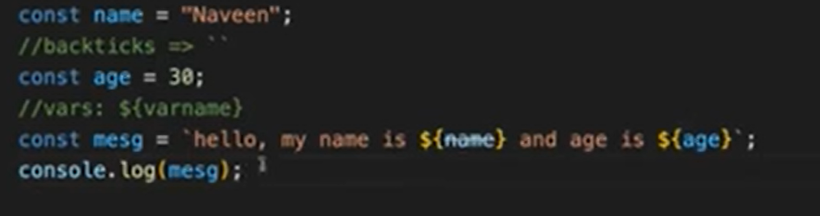

## If we write 3 lines of sentences using double quotes it is showing error and not allowing us to write it in that way so if we use backtick operator it will not show error.

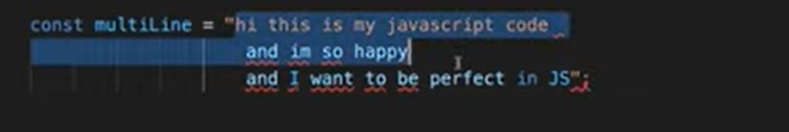

## This will print the sentence in same way how we declared in the variable.

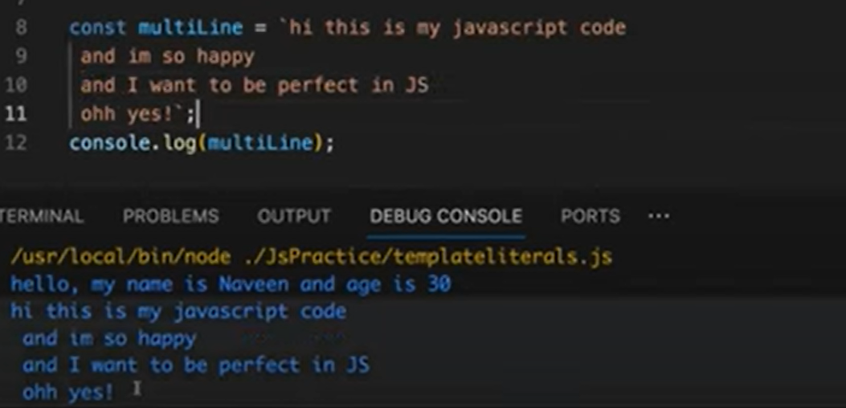

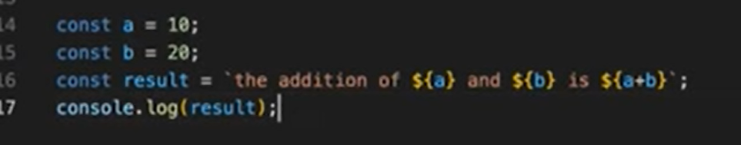

# To append the value in xpath:

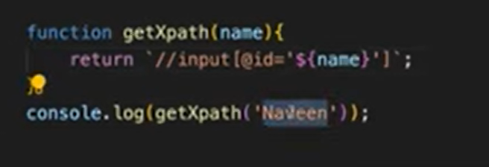

# Tom’s (to use this kind of sentence also we can use this backtick)



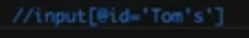

# Can we overload a function in JavaScript?

## There is no method overloading concept in JavaScript.

## In JavaScript we don’t give any datatype of the variable so here it will not be decided which method has to be called here.

## If we have 3 methods with same name and different parameters, then during run time it will execute the last method even if you pass the argument of first one also.

## It will always consider the latest one written in the code.

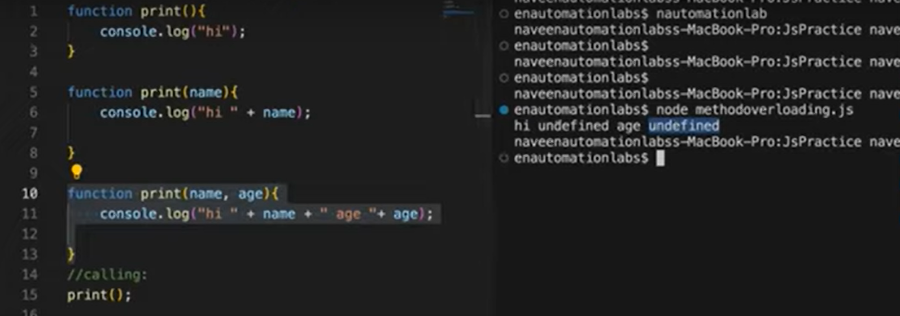

# Instead of writing with if and else we can write different methods.

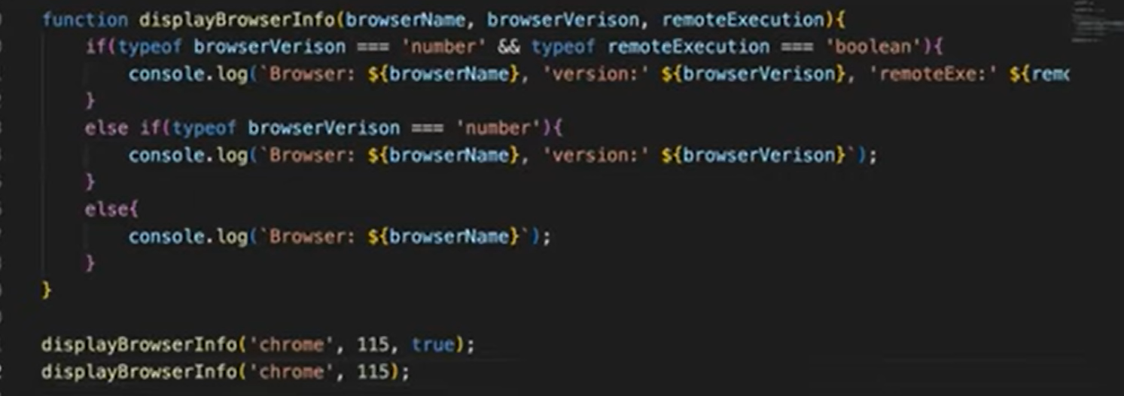

# Export

## First export this class and make this class visible to public so that anyone can import it.



# import

## Import that class into some other class then use keyword require.



# require

## Require-What class you want, and we are exporting class itself. Capture the class using creating one constant(Person)

# JavaScript Tips

# Find unique values from the array:

## […new Set(array)] = Spread operator

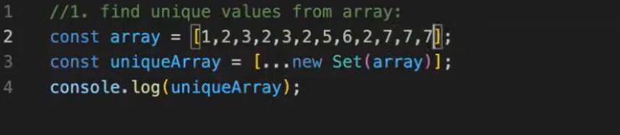

# Convert integer to String:

## Using space and String Constructor.

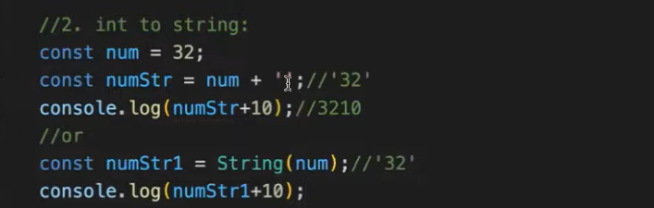

# Convert float to int:

## It removes .76 and return only 3

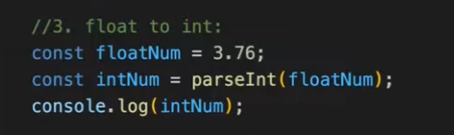

# Check if a variable is a number:

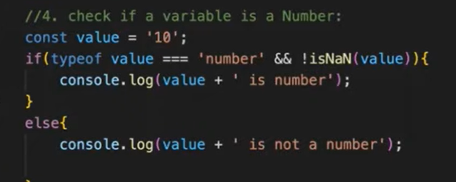

# Swap

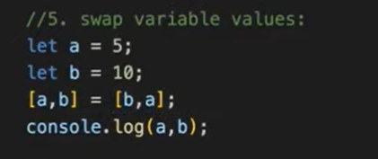

# Check if object has property:

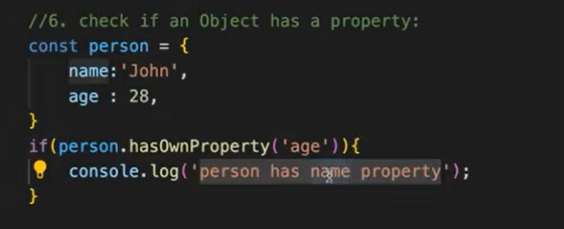

# Remove Falsy values:

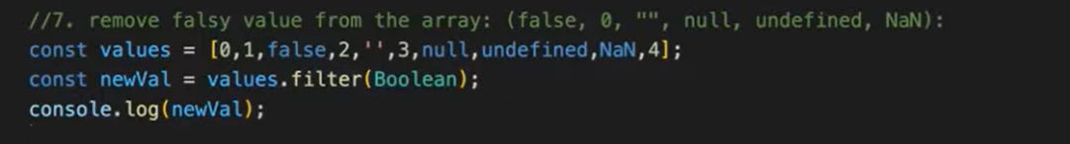

# Upper case and Lower Case

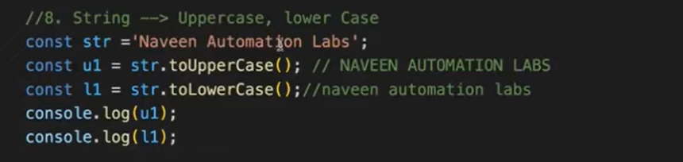

# Check if array contains specific values or not:

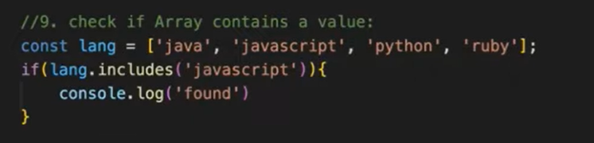

# Check the array is empty or not:

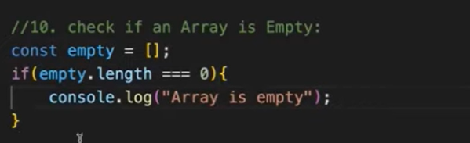

# Generate a random number between two numbers

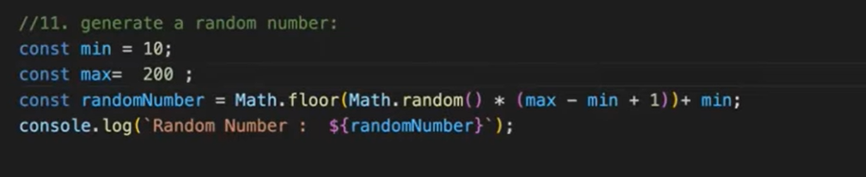

# Convert String to number:

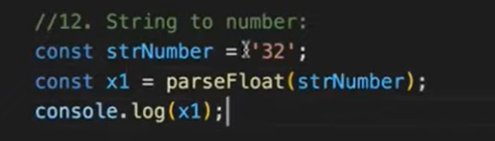

## If number is decimal, then it will return the decimal value in number format when using parseFloat.

# Join array elements into a string:

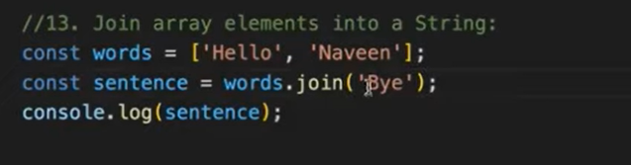

# Get Specific Object property:

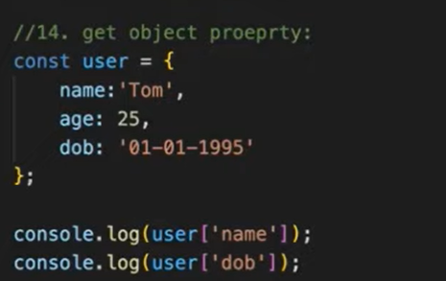

# Clone an array or object: Using spread operator

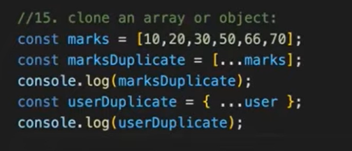

# Convert Object to array:

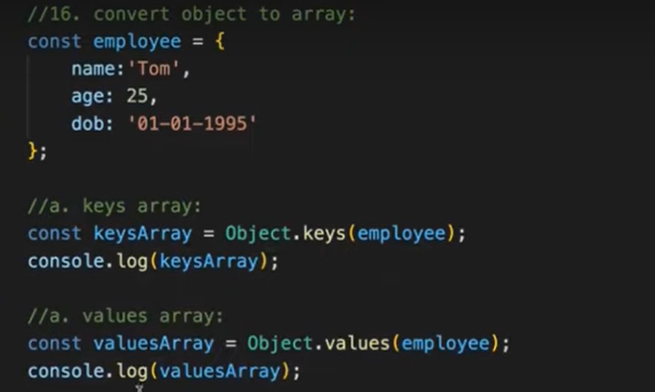

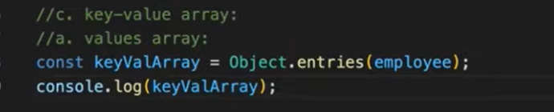

# Fetch current date and time:

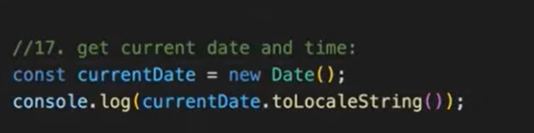

# Variable is defined or not:

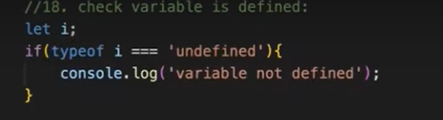

# Truncate an array: Manipulate the length of array:

## It will give the first 3 initial values.

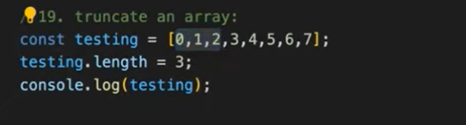

# Last item in an array

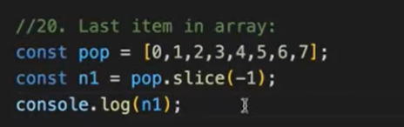

# Reverse a number:

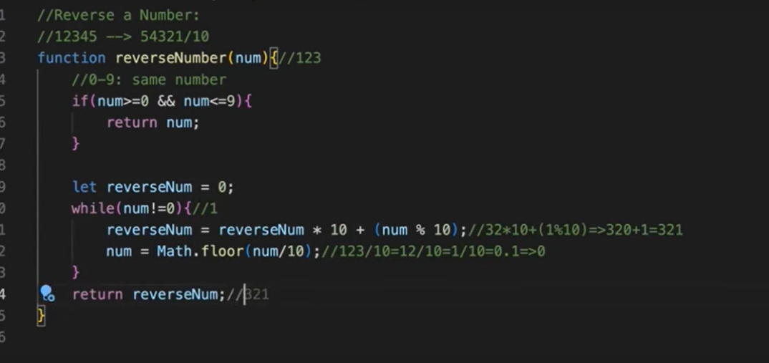

# Remove duplicate elements in array:

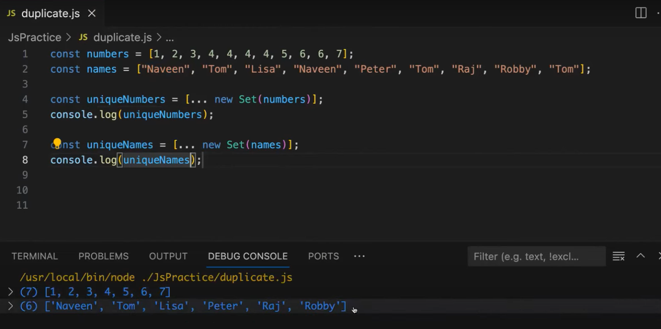

# De-structuring:

## De-structuring is a JavaScript expression that allows us to extract data from arrays, objects, and maps and set them into new, distinct variables.

# Array

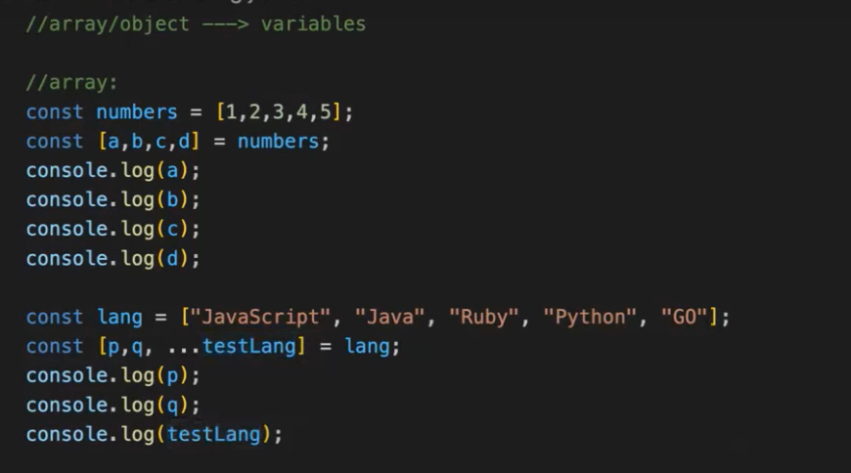

# Object

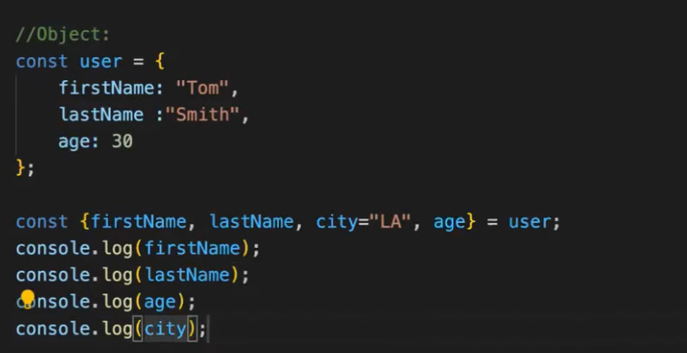

# Function

# Without De-structuring

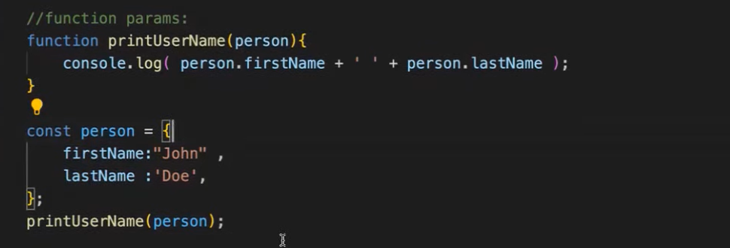

# With De-structuring

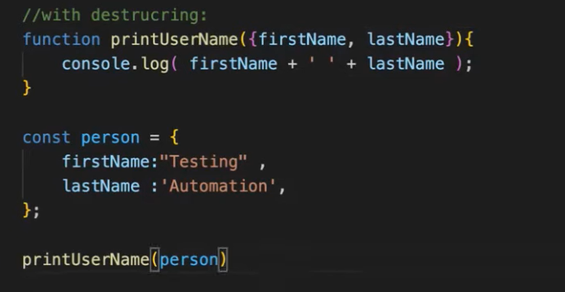

# Fetch API

